## Working with the Addin

1. Double Click the addin to Install in ArcMap
2. Load the Extension
3. Customize 🡪 Extensions

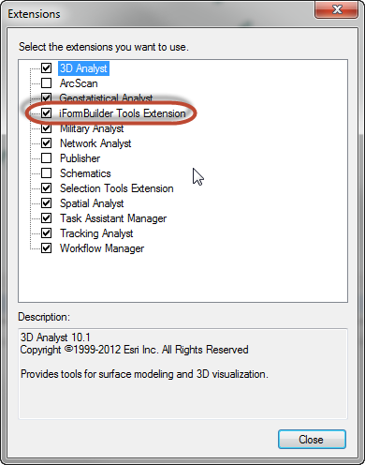

1. Add the toolbar to you ArcMap



1. Click the Settings Button on the toolbar



1. This will bring up the iForms Configuration Window
2. Load the Configuration File

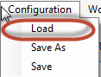

1. Point to the config_wv.xml
2. Create a new workspace (or set to an existing one)

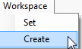

1. This will populate a list in the dropdown menu



1. Select the form you want to download
2. Click the data download button



1. Watch the Geoprocessing results window

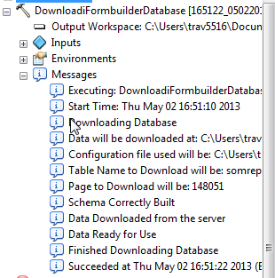

## Setting Up the Configuration File

## 

1. iFormBuilder Server URL
   1. This refers to the iFormbuilder instance ie: esri
      1. *The full path is not needed just the instance name
2. iFormBuilder Username
   1. Administrative user for the IFormBuilder site. This users needs to be able to access the data and the API functions
3. iFormBuilder Password
   1. Administrative Password for the the Administrative User
4. iFormBuilder Client ID
   1. Client ID for the iFormBuilder site
   2. Obtaining the Client ID
      1. Log into iFormBuilder account with an admin user
      2. Go to the Company Info
      3. 
      4. Go to the API Access and Click Show Client Key
      5. 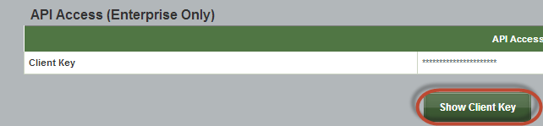
      6. Copy the Number that shows up
5. iFormBuilder Refresh Code
   1. This code is used in obtaining tokens (with username,password) for accessing the site
   2. Obtaining the Refresh Code
      1. Once the Client Key is obtained Click the API Explorer
      2. 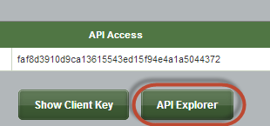
      3. Click the Get Access Code
      4. 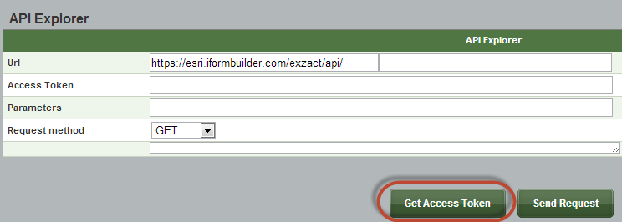
      5. A Request will Pop Up for your client key
      6. 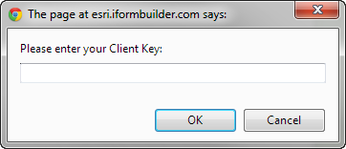
      7. Enter your Client Key from previous step
      8. Click OK
      9. A new window will open with and access token, refresh code
      10. 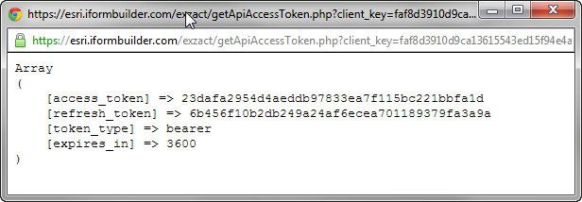
      11. Copy the Refresh Token and paste into the Configuration Window
6. iFormBuilder Profile Id
   1. Profile for the account
   2. Obtaining the Profile ID
      1. On the iFormBuilder Site in the upper right hand corner
      2. 
7. ArcGIS URL
   1. URL used for authenticating the user
      1. This should stay as <http://arcgis.com> rather than the organization since the authentication will hande which organization the user is a part of
8. ArcGIS Username
   1. Organization account for the user to login with
9. ArcGIS Password
   1. Organization account for the user to login with